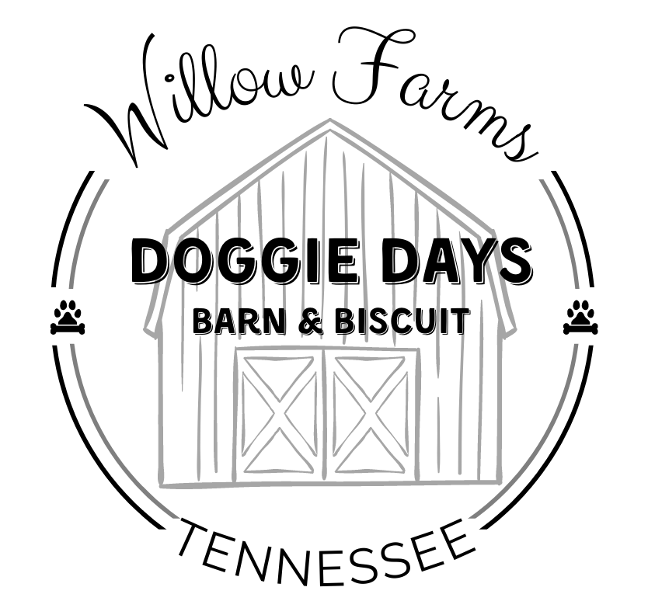

Willow Farms, LLC
Doggie Days Barn & Biscuit
2696 Threadgill Road, Huron, TN 38345
call/text: (731) 803-1136
email: willowfarmstn@gmail.com
website: www.willowfarmstn.com
____________________________________________________
Boarding Agreement

This agreement is by, between, and among Willow Farms, LLC Doggie Days Barn & Biscuit (“Doggie Days B&B”) and _________________________________________ (“Owner” or “Owners”). In consideration of the mutual promises and covenants contained herein, which the parties hereby irrevocably acknowledge to be sufficient, just, and adequate, the parties agree as follows:

- Owner agrees to pay all costs and charges in effect on the date that the pet is checked into Doggie Days B&B. Such rates and costs are set forth on the Hours & Rates Information Sheet. In addition to such amounts, Owner shall be responsible for all veterinary costs for the pet during the period that such pet is in the care of Doggie Days B&B.
- Owner agrees that the pet shall not leave the facility until all charges are paid by Owner or proper payment arrangements are agreed upon by the parties.
- Owner represents and warrants that the information submitted by him/her regarding the Owner’s dog(s) is true and accurate.
- Owner acknowledges receipt of a copy of this Boarding Agreement and accompanying forms for Doggie Days B&B. Owner agrees to fully and completely abide by such rules and procedures. Doggie Days B&B reserves the right to refuse admittance or services to any pet for any reason at any time.
- Doggie Days B&B shall exercise reasonable care for the pet delivered by Owner. If interactive daycare is provided, Owner recognizes and accepts potential risks involved in such activity.
- Owner specifically represents that Owner is the sole owner of the pet, free and clear of all liens and encumbrances.
- It is expressly agreed by Owner and Doggie Days B&B that Doggie Days B&B’s liability, for any and all reasons, shall in no event exceed the lesser of the current chattel value of a dog of the same species or the sum of $400.00 per dog admitted, whichever is less. Owner further agrees to be solely responsible for any and all acts or behavior of said pet while it is in the care of Doggie Days B&B, including payment of all costs and expenses for injury or damages to any person or property caused by the pet.
- Owner specifically represents to Doggie Days B&B that, to Owner’s knowledge, the pet has not been exposed to any contagious diseases within a thirty-day period prior to check-in. If so exposed, Owner shall withhold said pet boarding at Doggie Days B&B until pet is symptom-free for a minimum of thirty (30) days or with written veterinary clearance. Owner further agrees to maintain currency of vaccinations as required by Doggie Days B&B policy for vaccination requirements, including, but not limited to, rabies, DHPP, and bordetella (kennel cough). All dogs must be free of fleas at the time of check-in.
- All charges incurred by Owner shall be payable upon pick-up of pet. Doggie Days B&B shall have, and is hereby granted, a lien on the pet for any and all unpaid charges resulting from services provided by Doggie Days B&B. The Owner hereby agrees that in the event charges are not paid when due in accordance with this Agreement, Doggie Days B&B may exercise its lien rights upon ten (10) days written notice given by Doggie Days B&B to Owner by certified mail to the address shown on this agreement. Doggie Days B&B may dispose of pet for any and unpaid charges, at private or public sale, in the sole discretion of Doggie Days B&B, and Owner specifically waives all statutory or legal rights to the contrary. If such sale does not generate sufficient funds to pay Owner’s charges, plus costs of sale, then Owner shall be liable for the difference. All monies realized at such sale, over and above the charges due and costs of sale, shall be paid to Owner.
- If pet becomes ill or injured, or if the state of the animal’s health otherwise requires professional attention, Doggie Days B&B, in its sole discretion, may engage the services of a veterinarian and administer medicine or give other requisite attention to the animal, and the expenses thereof shall be paid by the Owner. In no event shall Doggie Days B&B be held responsible for seeking or not seeking any such care.
- This Agreement contains the entire agreement between the parties. All terms and conditions of this Agreement shall be binding on the heirs, administrators, personal representatives, and assigns of the Owner. This Agreement shall remain in full force and effect for pet’s initial and subsequent stays, provided that Doggie Days B&B may alter, amend, or revoke this Agreement at any time.
- Any controversy or claim arising out of or relating to this Agreement, whether sounding in tort, contract, or otherwise, shall first be submitted to mediation, the expense of which shall be borne equally by the parties. In the event that such mediation does not resolve the issue, such matter shall be resolved by a proceeding filed in the Chancery Court of Henderson County, Tennessee. The parties acknowledge and agree that such Court shall have sole and exclusive venue over all claims and controversies by, between, or among the parties relating in any way to services or charges by Doggie Days B&B. The parties hereby irrevocably consent to the personal jurisdiction and subject matter jurisdiction of the Chancery Court of Henderson County, Tennessee. THE PARTIES TO THIS AGREEMENT HEREBY IRREVOCABLY WAIVE ANY AND ALL CLAIMS TO A RIGHT TO A TRIAL BY JURY OF ANY CLAIMS, DEMANDS, OR ASSERTION, ALL IS MORE FULLY SET FORTH IN THIS PARAGRAPH 12.
- In the event that it is necessary for Doggie Days B&B to engage an attorney in connection with the collection of any amounts owed under this Agreement, or any other issue relating to this Agreement, Owner agrees to be responsible for any and all expenses relating thereto, including a reasonable attorney’s fee.
- This Agreement shall be construed and interpreted pursuant to the laws of the State of Tennessee. This Agreement shall not be modified or changed by Owner except by a written instrument executed by all parties which expressly refers to this Agreement.

Willow Farms, LLC Doggie Days Barn & Biscuit

DATE: _________________________

BY: ______________________________________
Tangie Sweatman, Chief Executive Officer

Owner(s):

DATE: __________________________

BY: ______________________________ _______________________________
Print Owner Name Owner Signature

______________________________ _______________________________
Print Owner Name Owner Signature

