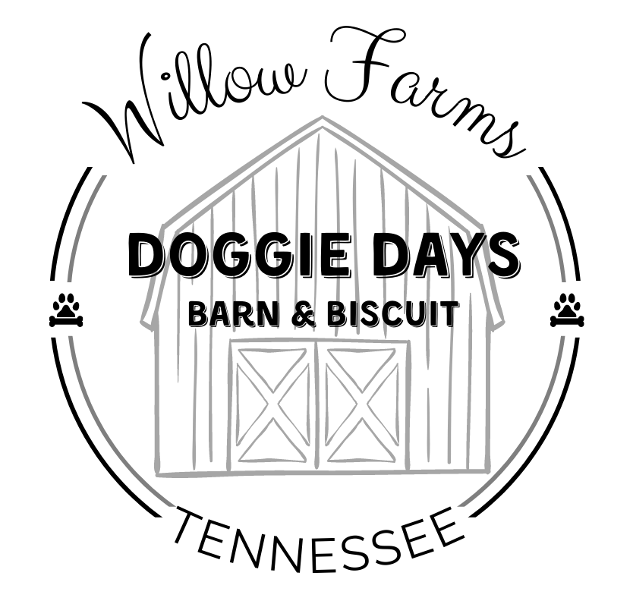

Willow Farms, LLC
Doggie Days Barn & Biscuit
2696 Threadgill Road, Huron, TN 38345
call/text: (731) 803-1136
email: willowfarmstn@gmail.com
website: www.willowfarmstn.com
____________________________________________________
Welcome to Willow Farms Doggie Days Barn & Biscuit!

Requirements for Boarding

All pets boarded at Willow Farms Doggie Days Barn & Biscuit must be current on vaccinations. We require proof of current vaccinations by a licensed veterinarian prior to your pet’s stay.

Required Vaccinations for Boarding
Rabies - 1 to 3 year (per your veterinarian)
DHPP - (Distemper/Parvo combination booster) - 1 to 3 year (per your veterinarian)
Bordetella - (Kennel Cough) - required annually

If we cannot confirm vaccinations were given by a licensed veterinarian, we will NOT be able to board your dog. We do NOT accept vaccinations done by breeders or pet owners.

We will do a brief pre-entry pet check upon arrival. This superficial check does not replace an exam performed by your licensed veterinarian.
The pet owner should notify us of any unusual situations (bumps, stitches, limping, allergies, etc.) If fleas or ticks are found, we will need to treat your pet prior to entering the kennel at the owner’s expense.

Male Dogs
Intact Male Dogs - Males dogs who are intact (not neutered) will be allowed to stay at our kennel. However, they will not be able to play with other guests if they are over six (6) months of age. Intact male dogs can emit hormones that can alter the behavior and reactions of other dogs. Separating intact male dogs from our spayed/neutered guests is for the best interest of all kennel guests.

Unaltered Male Dogs
(over one year of age)
$5.00 per night in addition to the night rates.
Female Dogs in Heat
Female dogs who are intact (not spayed) will be allowed to stay in our kennel. However, female dogs IN HEAT CANNOT BE BOARDED. They emit a scent that can alter the behavior and reactions of other dogs and can negatively impact the dynamic of the boarding experience for all guests. Therefore, for the safety and well-being of all our guests, female dogs in heat cannot be boarded.

Requirements for Boarding 03/15/22

